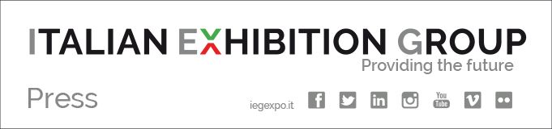

Press Release

ITALIAN EXHIBITION GROUP DEFINES THE TEAM
FOR ITS STOCK EXCHANGE LISTING PROJECT: THE APPOINTMENTS ASSIGNED TODAY

Rimini, 25th May 2018 – Another step on behalf of Italian Exhibition Group SpA (IEG) towards the listing of its shares in the STAR segment of the Italian Stock Exchange’s main equities market (MTA) with the formation of the work team.
In fact, the appointed team held its kick-off meeting today, during which it shared the strategies for the company’s consolidation and development and drew up the calendar of activities.
The work team is made up as follows:

Joint Global Coordinator: Equita SIM – Intermonte SIM
Placement agent for the retail offer: Equita SIM
Sponsor and Specialist: Intermonte SIM
Legal Advisors to issuer: Gianni, Origoni, Grippo, Cappelli & Partners
JGC Legal Advisor: DLA Piper Italia
Tax advisors: BP – Boldrini Pesaresi & Associati
PR and communication Advisors: Barabino & Partners
Auditors: PwC
Financial Advisor: Alantra

With the formation of this team, IEG intended availing itself of the services of high-profile professionals, in order to ensure its shareholders and the local area all the necessary attention to the operation of opening up to the stock markets, for which the schedule currently remains as already previously announced.

* * *
FOCUS ON ITALIAN EXHIBITION GROUP SPA::
Italian Exhibition Group SpA, with the two expo centres of Rimini and Vicenza, is Italy’s first trade fair organizer for profitability and expo portfolio (regarding the Food & Beverage, Green, Technology, Entertainment, Tourism, Transport, Wellness, Jewellery e Fashion, Lifestyle & Innovation trades). IEG operates worldwide, with branches in the United Arab Emirates, Brazil, United States and China. It is Italy’s leader in the conference-convention sector with Rimini’s Palacongressi and Vicenza Convention Centre. The IEG Group’s 2017 fiscal year closed with a consolidated turnover of 130.7 million euros. The Gross Operating Margin (EBITDA) as per 31st December 2017 was 23.2 million euros, whereas the consolidated Net Profit was 9.1 million euros. Group leader IEG S.p.A. ended the 2017 fiscal year with 109.4 million euros of revenue and a net profit of 8.7 million. www.iegexpo.it

* * *

IEG PRESS CONTACTS:
Elisabetta Vitali head of media & corporate communication, Marco Forcellini press office manager, Silvia Giorgi international press manager, Alessandro Caprio, Nicoletta Evangelisti Mancini, Jacopo Frenquellucci communication specialists media@iegexpo.it

